Downloading...
From: https://drive.google.com/uc?id=1VJaDVtDUtKQMmhRAqr3t-fgng899ZdRV
To: /content/Python Application Usage Log Data Set.xlsx
100%|██████████| 1.68M/1.68M [00:00<00:00, 108MB/s]
DEBUG:cmdstanpy:input tempfile: /tmp/tmpakk4y7wl/ef87syxd.json
DEBUG:cmdstanpy:input tempfile: /tmp/tmpakk4y7wl/25gndg9r.json
DEBUG:cmdstanpy:idx 0
DEBUG:cmdstanpy:running CmdStan, num_threads: None
DEBUG:cmdstanpy:CmdStan args: ['/usr/local/lib/python3.12/dist-packages/prophet/stan_model/prophet_model.bin', 'random', 'seed=62986', 'data', 'file=/tmp/tmpakk4y7wl/ef87syxd.json', 'init=/tmp/tmpakk4y7wl/25gndg9r.json', 'output', 'file=/tmp/tmpakk4y7wl/prophet_modelqyjdu7k9/prophet_model-20251025120738.csv', 'method=optimize', 'algorithm=lbfgs', 'iter=10000']
12:07:38 - cmdstanpy - INFO - Chain [1] start processing
INFO:cmdstanpy:Chain [1] start processing
12:07:45 - cmdstanpy - INFO - Chain [1] done processing
INFO:cmdstanpy:Chain [1] done processing
DEBUG:cmdstanpy:input tempfile: /tmp/tmpakk4y7wl/ag58tvrx.json
DEBUG:cmdstanpy:input tempfile: /tmp/tmpakk4y7wl/vubjqcfc.json
DEBUG:cmdstanpy:idx 0
DEBUG:cmdstanpy:running CmdStan, num_threads: None
DEBUG:cmdstanpy:CmdStan args: ['/usr/local/lib/python3.12/dist-packages/prophet/stan_model/prophet_model.bin', 'random', 'seed=20604', 'data', 'file=/tmp/tmpakk4y7wl/ag58tvrx.json', 'init=/tmp/tmpakk4y7wl/vubjqcfc.json', 'output', 'file=/tmp/tmpakk4y7wl/prophet_model91rrj_zz/prophet_model-20251025120747.csv', 'method=optimize', 'algorithm=lbfgs', 'iter=10000']
12:07:47 - cmdstanpy - INFO - Chain [1] start processing
INFO:cmdstanpy:Chain [1] start processing
12:07:53 - cmdstanpy - INFO - Chain [1] done processing
INFO:cmdstanpy:Chain [1] done processing
DEBUG:cmdstanpy:input tempfile: /tmp/tmpakk4y7wl/sobsrrce.json
DEBUG:cmdstanpy:input tempfile: /tmp/tmpakk4y7wl/go_1ulxz.json
DEBUG:cmdstanpy:idx 0
DEBUG:cmdstanpy:running CmdStan, num_threads: None
DEBUG:cmdstanpy:CmdStan args: ['/usr/local/lib/python3.12/dist-packages/prophet/stan_model/prophet_model.bin', 'random', 'seed=22308', 'data', 'file=/tmp/tmpakk4y7wl/sobsrrce.json', 'init=/tmp/tmpakk4y7wl/go_1ulxz.json', 'output', 'file=/tmp/tmpakk4y7wl/prophet_modelwpbyte11/prophet_model-20251025120753.csv', 'method=optimize', 'algorithm=lbfgs', 'iter=10000']
12:07:53 - cmdstanpy - INFO - Chain [1] start processing
INFO:cmdstanpy:Chain [1] start processing
12:07:59 - cmdstanpy - INFO - Chain [1] done processing
INFO:cmdstanpy:Chain [1] done processing
DEBUG:cmdstanpy:input tempfile: /tmp/tmpakk4y7wl/1itl_sjq.json
DEBUG:cmdstanpy:input tempfile: /tmp/tmpakk4y7wl/t4ifscpq.json
DEBUG:cmdstanpy:idx 0
DEBUG:cmdstanpy:running CmdStan, num_threads: None
DEBUG:cmdstanpy:CmdStan args: ['/usr/local/lib/python3.12/dist-packages/prophet/stan_model/prophet_model.bin', 'random', 'seed=58140', 'data', 'file=/tmp/tmpakk4y7wl/1itl_sjq.json', 'init=/tmp/tmpakk4y7wl/t4ifscpq.json', 'output', 'file=/tmp/tmpakk4y7wl/prophet_modelazu1lc9w/prophet_model-20251025120759.csv', 'method=optimize', 'algorithm=lbfgs', 'iter=10000']
12:07:59 - cmdstanpy - INFO - Chain [1] start processing
INFO:cmdstanpy:Chain [1] start processing
12:08:04 - cmdstanpy - INFO - Chain [1] done processing
INFO:cmdstanpy:Chain [1] done processing
DEBUG:cmdstanpy:input tempfile: /tmp/tmpakk4y7wl/k3l1rd2a.json
DEBUG:cmdstanpy:input tempfile: /tmp/tmpakk4y7wl/4ijj8g_k.json
DEBUG:cmdstanpy:idx 0
DEBUG:cmdstanpy:running CmdStan, num_threads: None
DEBUG:cmdstanpy:CmdStan args: ['/usr/local/lib/python3.12/dist-packages/prophet/stan_model/prophet_model.bin', 'random', 'seed=80306', 'data', 'file=/tmp/tmpakk4y7wl/k3l1rd2a.json', 'init=/tmp/tmpakk4y7wl/4ijj8g_k.json', 'output', 'file=/tmp/tmpakk4y7wl/prophet_modelvgzglvwd/prophet_model-20251025120805.csv', 'method=optimize', 'algorithm=lbfgs', 'iter=10000']
12:08:05 - cmdstanpy - INFO - Chain [1] start processing
INFO:cmdstanpy:Chain [1] start processing
12:08:09 - cmdstanpy - INFO - Chain [1] done processing
INFO:cmdstanpy:Chain [1] done processing
DEBUG:cmdstanpy:input tempfile: /tmp/tmpakk4y7wl/wxze38f1.json
DEBUG:cmdstanpy:input tempfile: /tmp/tmpakk4y7wl/_27qx8j4.json
DEBUG:cmdstanpy:idx 0
DEBUG:cmdstanpy:running CmdStan, num_threads: None
DEBUG:cmdstanpy:CmdStan args: ['/usr/local/lib/python3.12/dist-packages/prophet/stan_model/prophet_model.bin', 'random', 'seed=64884', 'data', 'file=/tmp/tmpakk4y7wl/wxze38f1.json', 'init=/tmp/tmpakk4y7wl/_27qx8j4.json', 'output', 'file=/tmp/tmpakk4y7wl/prophet_modeljny56r6j/prophet_model-20251025120809.csv', 'method=optimize', 'algorithm=lbfgs', 'iter=10000']
12:08:09 - cmdstanpy - INFO - Chain [1] start processing
INFO:cmdstanpy:Chain [1] start processing
12:08:13 - cmdstanpy - INFO - Chain [1] done processing
INFO:cmdstanpy:Chain [1] done processing
DEBUG:cmdstanpy:input tempfile: /tmp/tmpakk4y7wl/16zvrkkh.json
DEBUG:cmdstanpy:input tempfile: /tmp/tmpakk4y7wl/oaouf7m2.json
DEBUG:cmdstanpy:idx 0
DEBUG:cmdstanpy:running CmdStan, num_threads: None
DEBUG:cmdstanpy:CmdStan args: ['/usr/local/lib/python3.12/dist-packages/prophet/stan_model/prophet_model.bin', 'random', 'seed=42969', 'data', 'file=/tmp/tmpakk4y7wl/16zvrkkh.json', 'init=/tmp/tmpakk4y7wl/oaouf7m2.json', 'output', 'file=/tmp/tmpakk4y7wl/prophet_modeljo497z_v/prophet_model-20251025120813.csv', 'method=optimize', 'algorithm=lbfgs', 'iter=10000']
12:08:13 - cmdstanpy - INFO - Chain [1] start processing
INFO:cmdstanpy:Chain [1] start processing
12:08:19 - cmdstanpy - INFO - Chain [1] done processing
INFO:cmdstanpy:Chain [1] done processing
DEBUG:cmdstanpy:input tempfile: /tmp/tmpakk4y7wl/8amdtwd4.json
DEBUG:cmdstanpy:input tempfile: /tmp/tmpakk4y7wl/w5xpnrtk.json
DEBUG:cmdstanpy:idx 0
DEBUG:cmdstanpy:running CmdStan, num_threads: None
DEBUG:cmdstanpy:CmdStan args: ['/usr/local/lib/python3.12/dist-packages/prophet/stan_model/prophet_model.bin', 'random', 'seed=55682', 'data', 'file=/tmp/tmpakk4y7wl/8amdtwd4.json', 'init=/tmp/tmpakk4y7wl/w5xpnrtk.json', 'output', 'file=/tmp/tmpakk4y7wl/prophet_modelkva59loj/prophet_model-20251025120820.csv', 'method=optimize', 'algorithm=lbfgs', 'iter=10000']
12:08:20 - cmdstanpy - INFO - Chain [1] start processing
INFO:cmdstanpy:Chain [1] start processing
12:08:26 - cmdstanpy - INFO - Chain [1] done processing
INFO:cmdstanpy:Chain [1] done processing
DEBUG:cmdstanpy:input tempfile: /tmp/tmpakk4y7wl/487no1t8.json
DEBUG:cmdstanpy:input tempfile: /tmp/tmpakk4y7wl/zarisdgj.json
DEBUG:cmdstanpy:idx 0
DEBUG:cmdstanpy:running CmdStan, num_threads: None
DEBUG:cmdstanpy:CmdStan args: ['/usr/local/lib/python3.12/dist-packages/prophet/stan_model/prophet_model.bin', 'random', 'seed=28136', 'data', 'file=/tmp/tmpakk4y7wl/487no1t8.json', 'init=/tmp/tmpakk4y7wl/zarisdgj.json', 'output', 'file=/tmp/tmpakk4y7wl/prophet_model1fr_5220/prophet_model-20251025120826.csv', 'method=optimize', 'algorithm=lbfgs', 'iter=10000']
12:08:26 - cmdstanpy - INFO - Chain [1] start processing
INFO:cmdstanpy:Chain [1] start processing
12:08:30 - cmdstanpy - INFO - Chain [1] done processing
INFO:cmdstanpy:Chain [1] done processing
DEBUG:cmdstanpy:input tempfile: /tmp/tmpakk4y7wl/hr4wc93v.json
DEBUG:cmdstanpy:input tempfile: /tmp/tmpakk4y7wl/ikb5b29s.json
DEBUG:cmdstanpy:idx 0
DEBUG:cmdstanpy:running CmdStan, num_threads: None
DEBUG:cmdstanpy:CmdStan args: ['/usr/local/lib/python3.12/dist-packages/prophet/stan_model/prophet_model.bin', 'random', 'seed=6464', 'data', 'file=/tmp/tmpakk4y7wl/hr4wc93v.json', 'init=/tmp/tmpakk4y7wl/ikb5b29s.json', 'output', 'file=/tmp/tmpakk4y7wl/prophet_modellaqelxch/prophet_model-20251025120831.csv', 'method=optimize', 'algorithm=lbfgs', 'iter=10000']
12:08:31 - cmdstanpy - INFO - Chain [1] start processing
INFO:cmdstanpy:Chain [1] start processing
12:08:36 - cmdstanpy - INFO - Chain [1] done processing
INFO:cmdstanpy:Chain [1] done processing
DEBUG:cmdstanpy:input tempfile: /tmp/tmpakk4y7wl/ox4ss__w.json
DEBUG:cmdstanpy:input tempfile: /tmp/tmpakk4y7wl/9igij3_2.json
DEBUG:cmdstanpy:idx 0
DEBUG:cmdstanpy:running CmdStan, num_threads: None
DEBUG:cmdstanpy:CmdStan args: ['/usr/local/lib/python3.12/dist-packages/prophet/stan_model/prophet_model.bin', 'random', 'seed=3738', 'data', 'file=/tmp/tmpakk4y7wl/ox4ss__w.json', 'init=/tmp/tmpakk4y7wl/9igij3_2.json', 'output', 'file=/tmp/tmpakk4y7wl/prophet_modelqmp8iamw/prophet_model-20251025120837.csv', 'method=optimize', 'algorithm=lbfgs', 'iter=10000']
12:08:37 - cmdstanpy - INFO - Chain [1] start processing
INFO:cmdstanpy:Chain [1] start processing
12:08:39 - cmdstanpy - INFO - Chain [1] done processing
INFO:cmdstanpy:Chain [1] done processing
DEBUG:cmdstanpy:input tempfile: /tmp/tmpakk4y7wl/63m11fbo.json
DEBUG:cmdstanpy:input tempfile: /tmp/tmpakk4y7wl/l6k42jgy.json
DEBUG:cmdstanpy:idx 0
DEBUG:cmdstanpy:running CmdStan, num_threads: None
DEBUG:cmdstanpy:CmdStan args: ['/usr/local/lib/python3.12/dist-packages/prophet/stan_model/prophet_model.bin', 'random', 'seed=78460', 'data', 'file=/tmp/tmpakk4y7wl/63m11fbo.json', 'init=/tmp/tmpakk4y7wl/l6k42jgy.json', 'output', 'file=/tmp/tmpakk4y7wl/prophet_model3adpnr3v/prophet_model-20251025120840.csv', 'method=optimize', 'algorithm=lbfgs', 'iter=10000']
12:08:40 - cmdstanpy - INFO - Chain [1] start processing
INFO:cmdstanpy:Chain [1] start processing
12:08:45 - cmdstanpy - INFO - Chain [1] done processing
INFO:cmdstanpy:Chain [1] done processing
DEBUG:cmdstanpy:input tempfile: /tmp/tmpakk4y7wl/2oh2ua6z.json
DEBUG:cmdstanpy:input tempfile: /tmp/tmpakk4y7wl/wm32pxa2.json
DEBUG:cmdstanpy:idx 0
DEBUG:cmdstanpy:running CmdStan, num_threads: None
DEBUG:cmdstanpy:CmdStan args: ['/usr/local/lib/python3.12/dist-packages/prophet/stan_model/prophet_model.bin', 'random', 'seed=2619', 'data', 'file=/tmp/tmpakk4y7wl/2oh2ua6z.json', 'init=/tmp/tmpakk4y7wl/wm32pxa2.json', 'output', 'file=/tmp/tmpakk4y7wl/prophet_model5ahmipkf/prophet_model-20251025120845.csv', 'method=optimize', 'algorithm=lbfgs', 'iter=10000']
12:08:45 - cmdstanpy - INFO - Chain [1] start processing
INFO:cmdstanpy:Chain [1] start processing
12:08:50 - cmdstanpy - INFO - Chain [1] done processing
INFO:cmdstanpy:Chain [1] done processing
DEBUG:cmdstanpy:input tempfile: /tmp/tmpakk4y7wl/7jddlsip.json
DEBUG:cmdstanpy:input tempfile: /tmp/tmpakk4y7wl/nxp4t5dl.json
DEBUG:cmdstanpy:idx 0
DEBUG:cmdstanpy:running CmdStan, num_threads: None
DEBUG:cmdstanpy:CmdStan args: ['/usr/local/lib/python3.12/dist-packages/prophet/stan_model/prophet_model.bin', 'random', 'seed=13206', 'data', 'file=/tmp/tmpakk4y7wl/7jddlsip.json', 'init=/tmp/tmpakk4y7wl/nxp4t5dl.json', 'output', 'file=/tmp/tmpakk4y7wl/prophet_modelhrr6mrsz/prophet_model-20251025120851.csv', 'method=optimize', 'algorithm=lbfgs', 'iter=10000']
12:08:51 - cmdstanpy - INFO - Chain [1] start processing
INFO:cmdstanpy:Chain [1] start processing
12:08:56 - cmdstanpy - INFO - Chain [1] done processing
INFO:cmdstanpy:Chain [1] done processing
DEBUG:cmdstanpy:input tempfile: /tmp/tmpakk4y7wl/osqclci0.json
DEBUG:cmdstanpy:input tempfile: /tmp/tmpakk4y7wl/q9z0tga5.json
DEBUG:cmdstanpy:idx 0
DEBUG:cmdstanpy:running CmdStan, num_threads: None
DEBUG:cmdstanpy:CmdStan args: ['/usr/local/lib/python3.12/dist-packages/prophet/stan_model/prophet_model.bin', 'random', 'seed=56398', 'data', 'file=/tmp/tmpakk4y7wl/osqclci0.json', 'init=/tmp/tmpakk4y7wl/q9z0tga5.json', 'output', 'file=/tmp/tmpakk4y7wl/prophet_model1lgc75n_/prophet_model-20251025120856.csv', 'method=optimize', 'algorithm=lbfgs', 'iter=10000']
12:08:56 - cmdstanpy - INFO - Chain [1] start processing
INFO:cmdstanpy:Chain [1] start processing
12:09:04 - cmdstanpy - INFO - Chain [1] done processing
INFO:cmdstanpy:Chain [1] done processing
DEBUG:cmdstanpy:input tempfile: /tmp/tmpakk4y7wl/gbmiuwg9.json
DEBUG:cmdstanpy:input tempfile: /tmp/tmpakk4y7wl/bcb6pl67.json
DEBUG:cmdstanpy:idx 0
DEBUG:cmdstanpy:running CmdStan, num_threads: None
DEBUG:cmdstanpy:CmdStan args: ['/usr/local/lib/python3.12/dist-packages/prophet/stan_model/prophet_model.bin', 'random', 'seed=48119', 'data', 'file=/tmp/tmpakk4y7wl/gbmiuwg9.json', 'init=/tmp/tmpakk4y7wl/bcb6pl67.json', 'output', 'file=/tmp/tmpakk4y7wl/prophet_model4v6s99lq/prophet_model-20251025120904.csv', 'method=optimize', 'algorithm=lbfgs', 'iter=10000']
12:09:04 - cmdstanpy - INFO - Chain [1] start processing
INFO:cmdstanpy:Chain [1] start processing
12:09:07 - cmdstanpy - INFO - Chain [1] done processing
INFO:cmdstanpy:Chain [1] done processing
DEBUG:cmdstanpy:input tempfile: /tmp/tmpakk4y7wl/n1tsktbb.json
DEBUG:cmdstanpy:input tempfile: /tmp/tmpakk4y7wl/kqvo7ns9.json
DEBUG:cmdstanpy:idx 0
DEBUG:cmdstanpy:running CmdStan, num_threads: None
DEBUG:cmdstanpy:CmdStan args: ['/usr/local/lib/python3.12/dist-packages/prophet/stan_model/prophet_model.bin', 'random', 'seed=33445', 'data', 'file=/tmp/tmpakk4y7wl/n1tsktbb.json', 'init=/tmp/tmpakk4y7wl/kqvo7ns9.json', 'output', 'file=/tmp/tmpakk4y7wl/prophet_modelu80mlr0p/prophet_model-20251025120908.csv', 'method=optimize', 'algorithm=lbfgs', 'iter=10000']
12:09:08 - cmdstanpy - INFO - Chain [1] start processing
INFO:cmdstanpy:Chain [1] start processing
12:09:14 - cmdstanpy - INFO - Chain [1] done processing
INFO:cmdstanpy:Chain [1] done processing
DEBUG:cmdstanpy:input tempfile: /tmp/tmpakk4y7wl/tl2fteb7.json
DEBUG:cmdstanpy:input tempfile: /tmp/tmpakk4y7wl/lxjltusv.json
DEBUG:cmdstanpy:idx 0
DEBUG:cmdstanpy:running CmdStan, num_threads: None
DEBUG:cmdstanpy:CmdStan args: ['/usr/local/lib/python3.12/dist-packages/prophet/stan_model/prophet_model.bin', 'random', 'seed=99815', 'data', 'file=/tmp/tmpakk4y7wl/tl2fteb7.json', 'init=/tmp/tmpakk4y7wl/lxjltusv.json', 'output', 'file=/tmp/tmpakk4y7wl/prophet_modelk2we53ui/prophet_model-20251025120915.csv', 'method=optimize', 'algorithm=lbfgs', 'iter=10000']
12:09:15 - cmdstanpy - INFO - Chain [1] start processing
INFO:cmdstanpy:Chain [1] start processing
12:09:21 - cmdstanpy - INFO - Chain [1] done processing
INFO:cmdstanpy:Chain [1] done processing
DEBUG:cmdstanpy:input tempfile: /tmp/tmpakk4y7wl/8ntj2ery.json
DEBUG:cmdstanpy:input tempfile: /tmp/tmpakk4y7wl/j_y8z8mx.json
DEBUG:cmdstanpy:idx 0
DEBUG:cmdstanpy:running CmdStan, num_threads: None
DEBUG:cmdstanpy:CmdStan args: ['/usr/local/lib/python3.12/dist-packages/prophet/stan_model/prophet_model.bin', 'random', 'seed=77956', 'data', 'file=/tmp/tmpakk4y7wl/8ntj2ery.json', 'init=/tmp/tmpakk4y7wl/j_y8z8mx.json', 'output', 'file=/tmp/tmpakk4y7wl/prophet_modeljo0zly3d/prophet_model-20251025120922.csv', 'method=optimize', 'algorithm=lbfgs', 'iter=10000']
12:09:22 - cmdstanpy - INFO - Chain [1] start processing
INFO:cmdstanpy:Chain [1] start processing
12:09:28 - cmdstanpy - INFO - Chain [1] done processing
INFO:cmdstanpy:Chain [1] done processing
DEBUG:cmdstanpy:input tempfile: /tmp/tmpakk4y7wl/kdnpuuqt.json
DEBUG:cmdstanpy:input tempfile: /tmp/tmpakk4y7wl/qmcvp0ms.json
DEBUG:cmdstanpy:idx 0
DEBUG:cmdstanpy:running CmdStan, num_threads: None
DEBUG:cmdstanpy:CmdStan args: ['/usr/local/lib/python3.12/dist-packages/prophet/stan_model/prophet_model.bin', 'random', 'seed=63669', 'data', 'file=/tmp/tmpakk4y7wl/kdnpuuqt.json', 'init=/tmp/tmpakk4y7wl/qmcvp0ms.json', 'output', 'file=/tmp/tmpakk4y7wl/prophet_modelw2u5635b/prophet_model-20251025120929.csv', 'method=optimize', 'algorithm=lbfgs', 'iter=10000']
12:09:29 - cmdstanpy - INFO - Chain [1] start processing
INFO:cmdstanpy:Chain [1] start processing
12:09:34 - cmdstanpy - INFO - Chain [1] done processing
INFO:cmdstanpy:Chain [1] done processing
DEBUG:cmdstanpy:input tempfile: /tmp/tmpakk4y7wl/g4_b9nry.json
DEBUG:cmdstanpy:input tempfile: /tmp/tmpakk4y7wl/oar_275y.json
DEBUG:cmdstanpy:idx 0
DEBUG:cmdstanpy:running CmdStan, num_threads: None
DEBUG:cmdstanpy:CmdStan args: ['/usr/local/lib/python3.12/dist-packages/prophet/stan_model/prophet_model.bin', 'random', 'seed=50476', 'data', 'file=/tmp/tmpakk4y7wl/g4_b9nry.json', 'init=/tmp/tmpakk4y7wl/oar_275y.json', 'output', 'file=/tmp/tmpakk4y7wl/prophet_modele8hcv540/prophet_model-20251025120935.csv', 'method=optimize', 'algorithm=lbfgs', 'iter=10000']
12:09:35 - cmdstanpy - INFO - Chain [1] start processing
INFO:cmdstanpy:Chain [1] start processing
12:09:41 - cmdstanpy - INFO - Chain [1] done processing
INFO:cmdstanpy:Chain [1] done processing
Top-3 Prophet cfgs: [{'changepoint_prior_scale': 1.0, 'seasonality_mode': 'multiplicative'}, {'changepoint_prior_scale': 0.8, 'seasonality_mode': 'multiplicative'}, {'changepoint_prior_scale': 0.5, 'seasonality_mode': 'multiplicative'}]
LSTM ensemble: [{'win': 21}, {'win': 28}] | Calibration: Isotonic
HOLDOUT (28d) — MAE: 445.67 | RMSE: 538.87 | MAPE: 13.24% | Accuracy: 86.76%
Prophet-ensemble HOLDOUT MAPE: 10.51% → ΔMAPE vs Hybrid: -2.73 pts

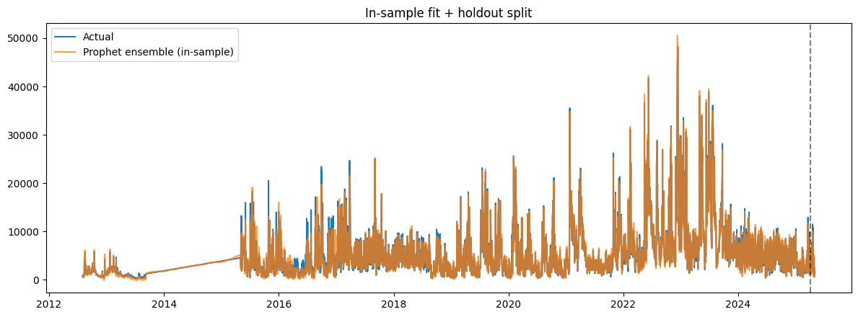
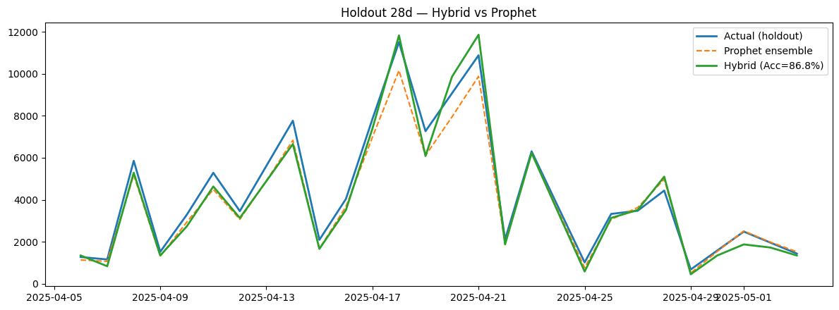
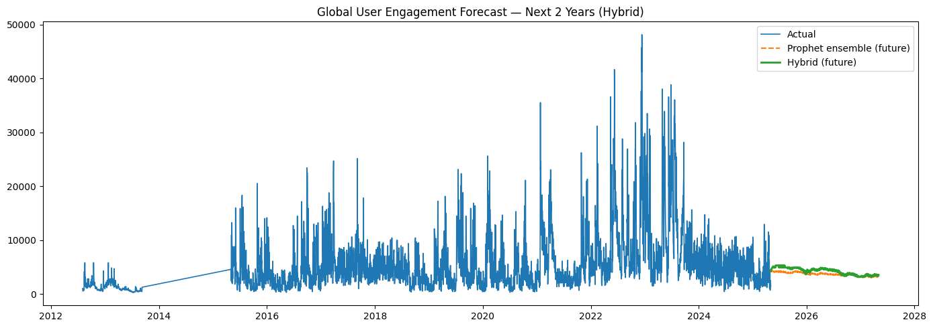
WARNING:absl:You are saving your model as an HDF5 file via `model.save()` or `keras.saving.save_model(model)`. This file format is considered legacy. We recommend using instead the native Keras format, e.g. `model.save('my_model.keras')` or `keras.saving.save_model(model, 'my_model.keras')`.

Artifacts: /content/hybrid_97acc_artifacts
- 2year_forecast.csv
- lstm_residual.h5
- metrics.json
- prophet_ensemble_cfgs.npy
- prophet_global.json
- x_scaler.npy
- y_scaler.npy

Checkpoints: /content/v3_ultrafast_ckpts
- lstm_v5_win21_uni.keras
- lstm_v5_win28_bi.keras
[None, None]

